IRSTI: 03.20

© М.S. Issayev^{1*}, T.A. Apendiyev², L.S. Dinasheva³, 2025.
¹Khoja Akhmet Yassawi International Kazakh-Turkish University, Turkistan, Kazakhstan;
^{2*}Ch.Ch. Valikhanov Institute of History and Ethnology; Almaty Management University,
Almaty, Kazakhstan;
³International University of Tourism and Hospitality, Turkestan, Kazakhstan.
Е-mail: mukhtar.issayev@ayu.edu.kz +7 777 777 77 77

EFFECTIVENESS OF USING DIGITAL AND INTERACTIVE MAPS IN TEACHING HISTORY

Mukhtar Issayev — PhD, Khoja Akhmet Yassawi International Kazakh-Turkish University, Kazakhstan,
Е-mail: mukhtar.issayev@ayu.edu.kz, https://orcid.org/0000-0001-7107-3993;
Timur Apendiyev — PhD, Ch.Ch. Valikhanov Institute of History and Ethnology, Almaty Management University, Kazakhstan,
Е-mail: timur.apendiev@mail.ru, https://orcid.org/0000-0002-4279-3921;
Lazat Dinasheva — Candidate of Historical Sciences, professor, International University of Tourism and Hospitality, Kazakhstan,
Е-mail: lazat.dinasheva@iuth.edu.kz, https://orcid.org/0000-0003-0831-4162.

Abstract. Today, due to the rapid development of society and technology, significant changes are taking place in the field of education. Traditional teaching methods are complemented by modern approaches based on the use of information and digital technologies. These changes lead to a new view of the goals and objectives of education. There is an increasing need to use new technology tools to enable students to achieve learning outcomes. The purpose of the article is to theoretically substantiate the effectiveness of using digital and interactive maps as a tool for developing students’ historical knowledge. To achieve this goal, the effectiveness of using digital and interactive maps to enhance the assimilation of historical content was assessed. The study drew conclusions about the current advantages and future prospects of integrating these maps into history teaching. The research results showed that digital and interactive maps play an important role in the educational process, including the teaching of history. During the scientific research, methods were used to analyze and compare pedagogical, psychological, methodological literature, and sites with cartographic resources. Digital and interactive maps depict historical events in space and time, allowing students to see complex connections. In particular, it was concluded that interactive maps are an accessible tool that allows students to apply their knowledge in practice, explore various historical issues and work independently. In the near future, digital and interactive maps are likely to become an integral part of history education. Scientific results can be effectively used in institutions where historical and educational activities are carried out.
Keywords: History of Kazakhstan, teaching history, innovative teaching methods, teaching aids, digital and interactive map, historical knowledge, students

Acknowledgement: The article was prepared within the framework of the grant financing project of the Ministry of Science and Higher Education of the Republic of Kazakhstan «Development of teaching methods for the subject «History of Kazakhstan» to future teachers of history using information and digital technologies» for 2023–2025. (IRN: AP19679946).

© М.С. Исаев^{1*}, Т.А. Апендиев², Л.С. Динашева³, 2025.
¹Қожа Ахмет Ясауи атындағы Халықаралық қазақ-түрік университеті, Түркістан, Қазақстан;
²Ш. Уәлиханов атындағы Тарих және этнология институты; Алматы менеджмент университеті, Алматы, Қазақстан;
³ Халықаралық туризм және меймандостық университеті, Түркістан, Қазақстан.
Е-mail: mukhtar.issayev@ayu.edu.kz

ТАРИХТЫ ОҚЫТУДА ЦИФРЛЫҚ ЖӘНЕ ИНТЕРАКТИВТІ КАРТАЛАРДЫ ПАЙДАЛАНУДЫҢ ТИІМДІЛІГІН ТАЛДАУ

Мұхтар Исаев — PhD, Қожа Ахмет Ясауи атындағы Халықаралық қазақ-түрік университеті, Түркістан, Қазақстан,
Е-mail: mukhtar.issayev@ayu.edu.kz, https://orcid.org/0000-0001-7107-3993;
Тимур Апендиев — PhD, Ш. Уәлиханов атындағы Тарих және этнология институты; Алматы менеджмент университеті, Алматы, Қазақстан,
Е-mail: timur.apendiev@mail.ru, https://orcid.org/0000-0002-4279-3921;
Ләззат Динашева — т.ғ.к., профессор, Халықаралық туризм және меймандостық университеті, Түркістан, Қазақстан,
Е-mail: lazat.dinasheva@iuth.edu.kz, https://orcid.org/0000-0003-0831-4162.

Аннотация. Мақалада қоғам мен технологиялардың қарқынды дамуына байланысты білім беру саласында жүріп жатқан маңызды өзгерістер талданады. Дәстүрлі оқыту әдістерін ақпараттық және цифрлық технологияларға негізделген заманауи тәсілдер толықтыруда. Бұл үрдіс білім беру мақсаттары мен міндеттеріне жаңаша көзқараспен қарауды талап етеді. Қазіргі таңда білім алушылардың оқу нәтижелеріне тиімді жетуіне мүмкіндік беретін жаңа технологиялық құралдарды пайдалану қажеттілігі артып келеді. Мақаланың мақсаты – білім алушылардың тарихи білімдерін қалыптастыру құралы ретінде цифрлық және интерактивті карталарды пайдаланудың тиімділігін теориялық тұрғыдан негіздеу. Осы мақсатқа жету үшін тарихи мазмұнды меңгеруді жақсартуға бағытталған цифрлық және интерактивті карталарды қолданудың артықшылықтары мен тиімділігі бағаланды. Зерттеу барысында педагогикалық, психологиялық және әдістемелік әдебиеттерге талдау жасау, картографиялық ресурстары бар веб-платформаларды зерттеу және салыстырмалы талдау әдістері қолданылды. Алынған нәтижелер цифрлық және интерактивті карталардың білім беру үдерісінде, әсіресе тарих пәнін оқытуда, маңызды рөл атқаратынын көрсетті. Бұл құралдар тарихи оқиғаларды кеңістіктік және уақыттық байланыста бейнелеу арқылы білім алушылардың күрделі себеп-салдарлық байланыстарды түсіну қабілетін арттырады. Зерттеу қорытындысы бойынша интерактивті карталар студенттерге алған білімдерін тәжірибеде қолдануға, түрлі тарихи мәселелерді өздігінен зерттеуге және оқу мотивациясын арттыруға мүмкіндік беретін тиімді құрал екені анықталды. Болашақта цифрлық және интерактивті карталар тарихты оқытудың ажырамас бөлігіне айналуы ықтимал. Алынған ғылыми нәтижелер тарихи білім беруді жүзеге асыратын білім беру ұйымдарында тиімді пайдаланылуы мүмкін.
Түйін сөздер: Қазақстан тарихы, тарихты оқыту, инновациялық оқыту әдістері, оқыту құралдары, цифрлық және интерактивті карта, тарихи білім, білім алушылар

© М.С. Исаев^{1*}, Т.А. Апендиев², Л.С. Динашева³, 2025.
¹Международный казахско-турецкий университет имени Ходжа Ахмеда Ясави,
Туркестан, Казахстан;
²Институт истории и этнологии им. Ч.Ч. Валиханова; Алматинский университет менеджмента, Алматы, Казахстан;
³Международный университет туризма и гостеприимства, Туркестан, Казахстан.
Е-mail: mukhtar.issayev@ayu.edu.kz

ЭФФЕКТИВНОСТЬ ИСПОЛЬЗОВАНИЯ ЦИФРОВЫХ И ИНТЕРАКТИВНЫХ КАРТ В ОБУЧЕНИИ ИСТОРИИ

Мухтар Исаев — PhD, Международный казахско-турецкий университет имени Ходжа Ахмеда Ясави, Туркестан, Казахстан,
Е-mail: mukhtar.issayev@ayu.edu.kz, https://orcid.org/0000-0001-7107-3993;
Тимур Апендиев — PhD, Институт истории и этнологии им.Ч.Ч. Валиханова; Алматинский университет менеджмента, Алматы, Казахстан,
Е-mail: timur.apendiev@mail.ru, https://orcid.org/0000-0002-4279-3921;
Лаззат Динашева — к.и.н., профессор, Международный университет туризма и гостеприимства, Туркестан, Казахстан,
Е-mail: lazat.dinasheva@iuth.edu.kz, https://orcid.org/0000-0003-0831-4162.

Аннотация. В настоящее время, в связи со стремительным развитием общества и технологий, в сфере образования происходят существенные изменения. Традиционные методы обучения дополняются современными подходами, основанными на использовании информационных и цифровых технологий. Эти трансформации способствуют переосмыслению целей и задач образования. Возрастает потребность в применении новых технологических инструментов, обеспечивающих достижение учащимися высоких образовательных результатов. Цель статьи — теоретически обосновать эффективность использования цифровых и интерактивных карт как инструмента формирования исторических знаний учащихся. Для достижения поставленной цели была проведена оценка эффективности применения цифровых и интерактивных карт в процессе усвоения исторического содержания. В ходе исследования сделаны выводы о современных преимуществах и перспективных возможностях внедрения данных карт в преподавание истории. Результаты показали, что цифровые и интерактивные карты играют значимую роль в образовательном процессе, в частности при изучении истории. В научной работе использовались методы анализа и сравнения педагогической, психологической и методической литературы, а также изучения интернет-ресурсов, содержащих картографические материалы. Цифровые и интерактивные карты позволяют визуализировать исторические события в пространственно-временном контексте, помогая учащимся лучше осмыслить сложные взаимосвязи между ними. Сделан вывод о том, что интерактивные карты являются доступным и эффективным инструментом, позволяющим учащимся применять знания на практике, самостоятельно исследовать исторические вопросы и развивать аналитическое мышление. В перспективе цифровые и интерактивные карты могут стать неотъемлемой частью преподавания истории. Полученные научные результаты могут быть использованы в образовательных учреждениях, реализующих историко-просветительские программы.
Ключевые слова: История Казахстана, преподавание истории, инновационные методы обучения, учебные пособия, цифровая и интерактивная карта, исторические знания, обучающиеся

Introduction. Today, the issue related to the formation of historical knowledge and increasing the interest of students studying in any educational institutions to learn about the past of their people and their motivation to study is becoming urgent. Therefore, there is an increasing need to search for effective, modern technologies and tools for the formation of historical knowledge.
In this context, first of all, it is necessary to create the necessary conditions for students to effectively master historical knowledge. Students will have a deeper understanding of historical knowledge if they experience and accept events in their own lives, not only when they study them externally. It should be noted that in historical education, not enough attention is paid to modern educational tools that help to perceive the events of the past in their true state. It is very important to use modern tools to make the learning process interesting and effective in history subjects.
As visual aids in the subject of history, maps serve a variety of purposes and are used for a variety of purposes. The use of digital and interactive maps based on new technologies increases the clarity of historical content and expands their role and scope of application. However, the scope and functions of digital and interactive maps in history lessons are not limited to this. Digital and interactive maps have a variety of other features and can be used for many purposes. Also, the rapid development of technologies in the field related to digital and interactive maps is the reason for the emergence of new and different teaching methods.
Literary review. There has been much research on the use of maps in history lessons. T. Turlygul (Turlygul, 2003), H. Tursun (Tursun, 2004), A.Sh. Zhurasova (Журасова, 2012) in their works extensively discuss the importance of using geographical maps as visual aids in history lessons. However, since information and digital technologies were not widely used during the period when these scientists conducted their research, the use of maps based on new technologies was not considered.
Foreign scholars Mohd Din (Mohd Din, 2005) and Selamat (Selamat, 2004) state in their research that they are concerned about the importance of achieving the main goals in teaching history. Often, "the learning process is focused on memorization and memorization of dates and facts, based solely on textbooks and focused on exams. Therefore, students quickly become bored in history classes and lose interest in studying history," he concludes. Therefore, it is necessary to pay special attention to modern tools that increase interest in studying history. Studies by Novak (Novak, 2005) and Novak and Govin (Novak and Gowin, 1984) show that the use of concept maps can help students learn. Because students are taught to graphically represent abstract information from text, it encourages logical, logical, and meaningful reading. The subject of history is abstract, complex and contains a lot of information that is difficult for students to understand. Therefore, using information and digital map tools helps students to perceive abstract concepts in history in a graphical way. N.V. Bekuzarova and O.I. Shumovsky (Lopatko, 2018), studying the role of interactive maps in the formation of historical knowledge, conclude that they allow preserving the integrity of the content of the presented material. I.A. Shchurinova (Shchurinova, 2016) believes that while highly appreciating the potential of electronic historical maps in teaching history at school, it is also necessary to take into account the risks of their use. According to the results of the study by M.Sari, A.A. Musadad, N. Suryani (Sari et al., 2018), the use of digital maps increases the ability of students to explain historical topics.
There are few studies on the use of digital maps in history education in Kazakhstan. It also appears that teachers are not sufficiently active in using teaching aids in history education. Therefore, the article examines the effectiveness of using digital and interactive maps in teaching history and their potential for building students' knowledge and skills.
Materials and methods. To explore the use of digital and interactive maps in history teaching, materials such as digital and interactive maps on websites, geographic information systems (GIS) (e.g., Google Earth, Google Map) were reviewed to obtain digital copies of maps and interactive objects. In addition, in studying the theoretical and methodological direction of the issue, educational programs and methodological materials, instructions and methodological tools for the effective use of digital maps, methods and approaches for students to complete tasks using digital maps, plans that define learning goals, assignments and projects for lessons, scientific research articles and books were reviewed and analyzed.
The educational content and structure analysis method was used to investigate the use of digital and interactive maps in history teaching. This method helps determine the effectiveness of maps in teaching history, the quality of the content, and the thematic relevance of the maps. Also, during the scientific research, methods of comparing pedagogical, psychological, and methodological literature were used. The above methods allowed us to study the effectiveness and features of using digital and interactive maps in teaching history.
Results. Maps are an important tool in teaching history because they allow learners to visually present historical information in space. Through maps, students see the location of historical events, the location of countries and peoples during that period, and the changing borders. Maps reveal not only geographical information, but also historical context. For example, by mapping trade routes in ancient times, we can understand economics, culture, religion, and other aspects. A map allows students to visually understand the situation of a particular historical period. The borders of countries, the territories of empires, the migration of peoples, and other historical processes are clearly shown on maps. It helps learners to see what changes have occurred over time and also to analyze the implications of those changes. According to a study conducted by Sari, “the following results are observed in the learning process by using interactive map media: (a) students' understanding of the learning material; (b) the ability to show places; (c) students' learning activity; (d) improvement in learning outcomes. The map allows students to improve their understanding of the historical subject and increase their ability to make explanations based on their knowledge” (Sari, 2014: 25). In addition, maps help learners understand the relationship between space and time. The use of digital and interactive maps through modern technologies will increase the effectiveness of history teaching. By working with maps, students will have the opportunity to conduct independent research, find answers to various questions, and compare different information. Interactive and digital maps allow students to be interested in history and engaged in the lesson. Through maps, students can actively participate in the process of studying history, looking with interest at historical periods and events that are unfamiliar to them.
Methods of using maps in history teaching help students better understand historical events, processes, and geographical locations. Maps are visual tools that allow learners to integrate time and space and gain a deeper understanding of historical events. Currently, the following methods of using maps are used in the teaching of history:
1. Analysis and interpretation of the map: Students explore geographic information displayed on maps and analyze maps to understand the distribution of historical events and processes. Here, a historian or teacher teaches students how to read a map correctly, interpret the information on it, and find important information about specific historical periods and events.
2. Showing Geographic Context: In the teaching of history, maps are used to show the geographical location of certain historical periods and events. For example, territorial changes during wartime, the expansion and collapse of empires, or trade routes and migrations are depicted through maps.
3. Explaining the chronology of historical events: Using maps, students can understand the chronology of certain events. For example, the First World War or the development of the Silk Road are taught through maps, and they show areas that have changed over time.
4. Comparing Maps: Comparing maps from different times is a useful technique to better understand historical events. This method allows us to show territorial changes in historical periods. For example, by comparing medieval and modern maps, you can see the borders of medieval states and understand historical processes.
5. Researching Myths and Legends: Maps are also sometimes useful in researching countries and places that appear in myths and legends. For example, maps can be useful for studying geographical names in ancient civilizations and their legends.
6. Depicting historical processes and changes: Maps are a useful tool for illustrating the dynamics of historical changes and processes. They provide a geographical representation of economic, cultural and political changes. For example, maps can be used to show how industrialization or urbanization occurred.
7. Interactive learning of history through maps: Using modern technologies, the use of digital maps and cartographic programs allows learners to study history through interactive methods. They can track real-time changes and data and explore interesting periods in history.
8. Debates and discussions: You can use maps to organize debates on historical issues and events. Using maps, you can discuss different perspectives on a particular historical event.
Through these methods, maps make teaching history easier and more interesting, and improve students' spatial and temporal understanding. Among the above methods, the advantages and features of using digital maps and cartographic programs in teaching with the help of modern technologies are evident.
Progress in information and communication technologies has also brought significant changes to cartography. These changes were mainly reflected in two main directions. First, instead of printing maps on paper or other materials, there was a transition to developing, storing, and displaying them in digital format. This change allowed for the introduction of new methods and features for creating maps. On the other hand, the development of web applications has increased the accessibility of maps and introduced significant changes in the organization of their sharing and collaboration. Nowadays, the Internet has become a primary and important tool for using maps (Ramos, 2006).
One of the main features of digital maps is that they are equipped with interactive applications. Such applications enrich the user experience by making maps dynamic. In addition, the user can make changes to the interactive maps according to their needs and goals. This allows you to customize the cards to your personal needs. Another advantage of interactive maps is that they provide high flexibility in their use. For example, the zoom in and out functions on maps allow you to view each part of the map in detail. This allows the map to present the necessary information in a clear and concise manner, without complicating its content.
In traditional methods, wall maps were often used in classrooms. However, in the context of higher education, there are often problems such as the availability of maps that are only for specific topics and in limited numbers, their rapid wear, and their sizes not matching the size of the audience. Digital and interactive maps have provided effective solutions to these problems and have allowed us to diversify the ways in which maps are used.
In classrooms equipped with computer and projection equipment, the teacher can use any digital and interactive map as a wall map. This significantly increases the number and types of cards used in the classroom. Teachers will have the opportunity to freely use the cards on various topics. Significant progress has also been made in the size of the maps. By positioning the projector according to the size and conditions of the audience, favorable conditions are created for displaying images of the required size.
Another important feature of digital and interactive maps is the inclusion of movement in maps. The ability to move gives maps a dynamic narrative language rather than a fixed narrative language. This offers significant advantages, especially in terms of depicting phenomena that change over time and space.
Digital and interactive maps allow the use of multimedia tools such as sound effects, three-dimensional visualizations, video content, and animated texts. The integration of these tools is essential to enrich the information on the maps and enhance the narrative. In the teaching of history, "the use of audiovisual media, including digital maps, has been shown to help students develop a sense of cause and effect, and to make learning student-centered and improve historical understanding" (Sari, 2014).
The ability to link to external sources and documents in digital and interactive maps enriches the information content of the map and provides users with quick and easy access to the necessary resources. Such links allow you to visually and easily display the data behind the information and resources contained in the map.
Digital and interactive maps allow for use on a variety of devices and platforms, which expands their scope of application. For example, digital maps can be used not only on computers, but also on mobile devices such as tablets and mobile phones. The Internet provides great opportunities in this regard. In addition, if multiple copies of the map are needed, the ability to quickly and easily reproduce digital maps stands out as an important advantage.
Discussions. Digital and interactive maps are very useful tools for organizing web-based learning activities. You can prepare various learning tasks and activities for students on the Internet based on digital maps. Google Earth and Google Maps are important examples of web tools used in history teaching. These two applications are provided by Google and contain similar content based on satellite images. Google Earth is primarily designed to show the Earth's natural features and geographic features, i.e., it provides a view of the Earth from space. Google Maps, on the other hand, focuses more on man-made structures, country borders, and city plans. The content of both tools is very extensive and diverse. In addition, through interactive features, users can enrich the content by adding information and documents they need.
Google Earth and Google Maps are used to conduct various educational activities for history students. These include adding information and data to historical sites, showing routes of military campaigns or research, studying historical monuments, creating maps (Figure 1, Figure 2), and constructing three-dimensional models of historical structures and cities (Park, 2009). Although Kazakhstan has the experience of using Google Earth in the subject of geography, this tool is still not widely used in the field of history education.

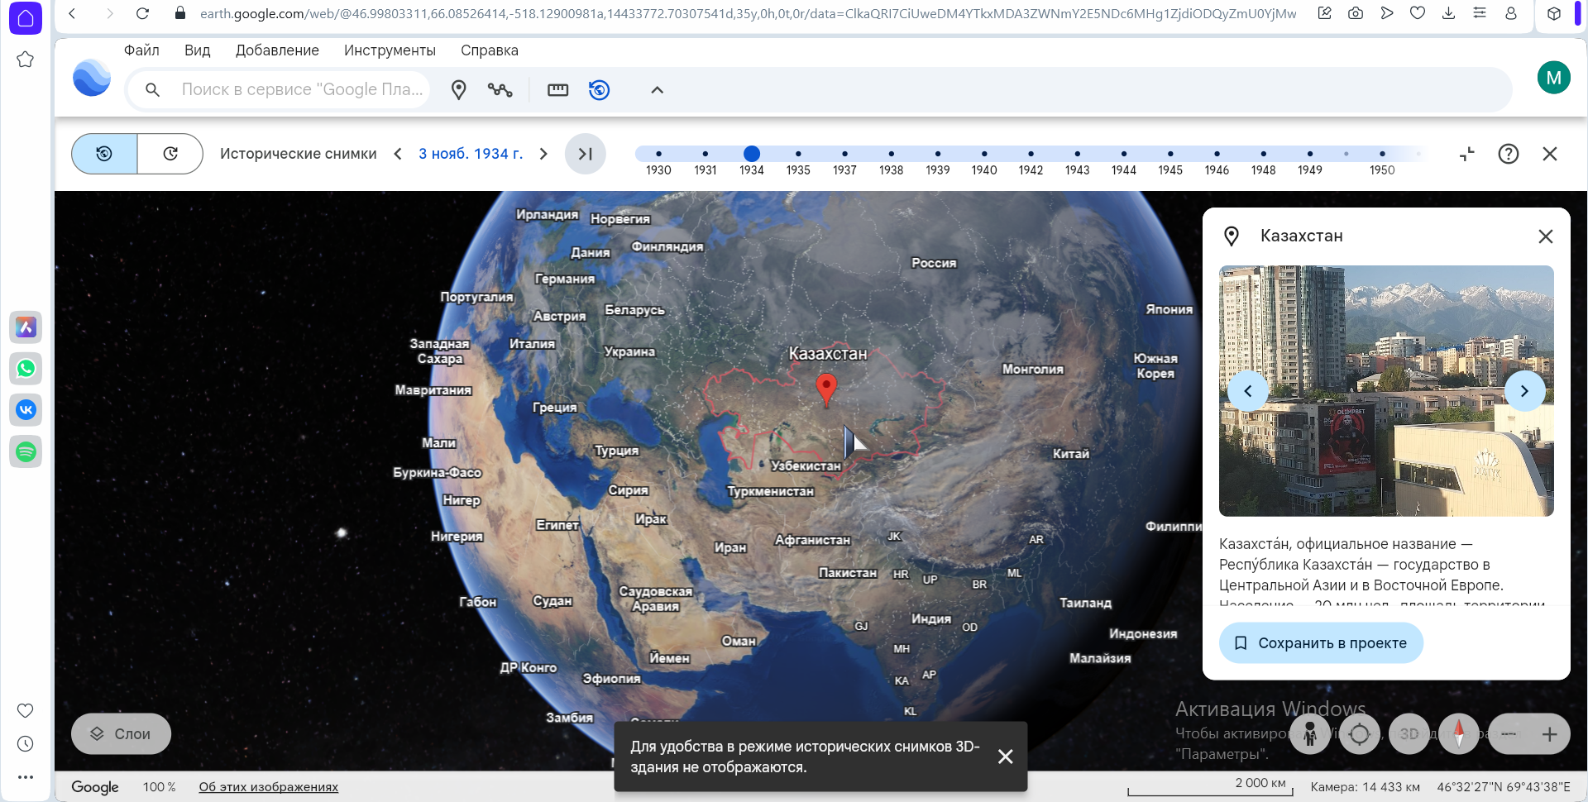
Figure 1 - Location of Kazakhstan on Google Earth

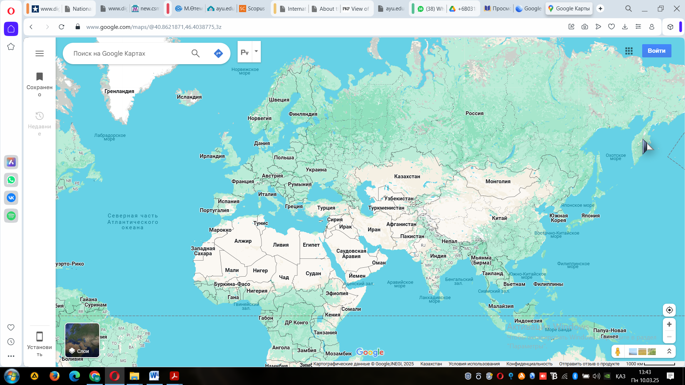
Figure 2 - View of state borders on Google Maps.

Most digital history maps are similar to classic printed maps and do not have any static or interactive elements. These maps are essentially digital copies of printed maps.
Another important advantage of these maps is the ability of students and teachers to make changes and additions to the maps. Using programs such as Paint, GIMP, Photoshop, teachers can easily edit static digital maps. This allows them to adapt them to their own teaching needs. In addition, it will be possible to translate maps in foreign languages ​​found on the Internet into Kazakh for students. Teachers can use PowerPoint and other programs to add elements of motion to static maps. Dynamic symbols can be added to maps to help students better understand spatial changes in historical events. Moving maps offer a significant advantage, especially in terms of showing students the progression of complex events and phenomena that have occurred over a long period of time (Hanewinkel, Tzschaschel, 2005).
Moving digital maps, which allow the user to influence the program, have many advantages in teaching history. Teachers can use the map according to the needs of their lessons and the characteristics of their students. An example of the advantages and features of such maps on the Internet is presented in Table 1 (Table 1).

Table 1. Foreign websites on the use of maps in teaching history.
№ | Websites | Features | Advantages
1 | http://users.erols.com/mwhite28/govt1970.htm | The website contains many moving maps of the border regions and leaders of various countries around the world in the 20th century. | A rich and well-rounded resource of moving digital maps organized in a chronological timeline.
2 | www.the-map-as-history.com веб-сайты | The moving maps on this website are organized in a video content format. | The video content format allows the user to pause, play forward, or rewind the map. Some maps are publicly available and free on the website.
3 | www.timemaps.com веб-сайты | The user clicks on the points shown on the timeline and sees a map showing the countries and civilizations of the world during the selected time period. | The World History Atlas on this site shows human history from 3900 BC to 2005 AD on an interactive digital map.
4 | https://geacron.com/home-en/ веб-сайты | The Interactive World History Atlas on this site displays human history from 3000 BC to 2022 AD on an interactive digital map. | The user clicks on the points shown on the timeline and sees a map showing the countries and civilizations of the world during the selected time period.

An interactive map is an electronic map that presents information with a geographic context. Such maps differ from other maps in terms of informativeness. Informativeness is associated with hidden data that is obtained when performing certain actions on the map, for example, the appearance of information when moving the cursor over an object.
Electronic maps are divided into several categories:
– Non-interactive, software-dependent maps;
– Interactive, software-dependent maps;
– Interactive, software-independent maps.
Using geocoding, any user can add their own data to the map, analyze the labels, or use their own labels to post the map on their website and share it with their audience (Бекузарова, 2018).
Some interactive history maps place all the content on a single map. The user clicks on interactive elements on the map to display the content they have selected. An example of an interactive map organized by sub-layers is shown on the website www.timemaps.com. The user clicks on one of the points located in different regions on a world map and accesses a new map that fully analyzes that region. For example, clicking on a link located in the Kazakhstan region opens the map shown in Figure 3. This map contains other links that include maps related to different regions of Europe. Thus, the user has the ability to navigate through multiple interconnected maps covering different periods and regions through a single map interface.

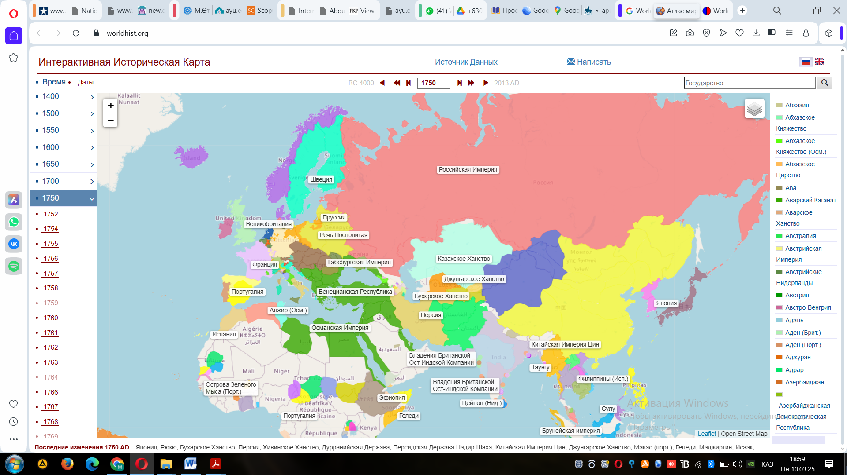
Figure 3 - Interactive map displayed on the website www.timemaps.com.

Digital historical cartography needs to be developed at a professional level in our country. The creation and publication of digital historical maps on the web is often carried out by non-professional individual initiatives. Most of the maps in Kazakh and Russian on the web are created by copying printed maps onto the Internet. Additionally, while it is possible to access many historical maps in Kazakh on the web, their archiving, classification, and presentation to teachers and students, as well as large-scale websites specializing in this area, have not yet emerged.
One of the resources that history teachers in Kazakhstan have access to digital maps is websites specifically designed to teach the history of Kazakhstan. As with other teaching materials, these sites (https://3d-maps.kz/kz_region_juz, http://www.tarih-begalinka.kz/kk/history/medieval/maps/, etc.) can use ready-made maps. Also, most general websites on the topic of history usually have historical maps, although they are usually small.
The Internet is also a rich resource for historical maps from past eras. The absence of copyright issues in the distribution of such maps by institutions such as universities, museums, libraries, and archives allows them to be digitally copied and shared openly and freely via the web. Historical maps are important materials for teaching history due to their wealth of information and the historical and geographical representation of the people of the era (Jessop, 2006). For example, the website of the National Library of Finland (https://kansalliskirjasto.finna.fi/) provides access to many historical maps related to the history of the Kazakh land (Figure 4). Maps related to Kazakh history can be viewed in the collections of other foreign libraries and archives that are similarly accessible.
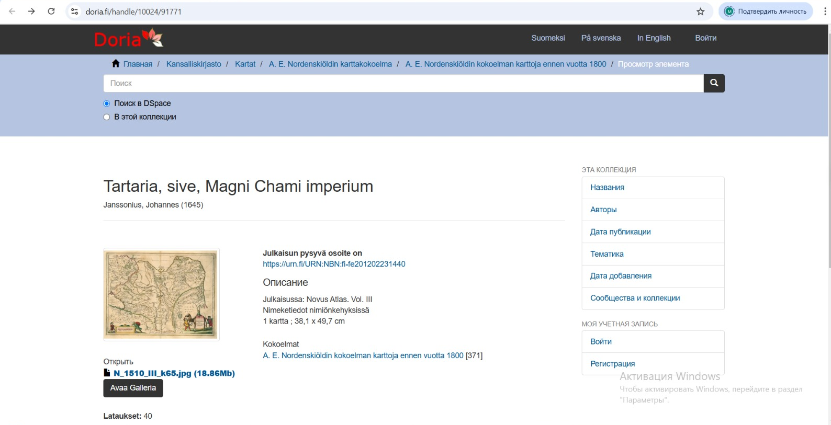
Figure 4. Website of the National Library of Finland providing access to historical maps.

The use of digital and interactive maps in history teaching increases students' interest in the subject and allows them to visually understand historical events and processes. These tools help students organize abstract and complex historical information in a graphical way, which ultimately contributes to deepening their historical knowledge. In addition, interactive maps increase students' motivation to learn and stimulate activity in the learning process.
Conclusion. Digital and interactive maps allow for a wide range of information in history teaching, allowing for the understanding and analysis of specific data. With the help of such maps, the learner can see complex connections by placing historical events in space and time. In particular, interactive maps allow students to apply their knowledge in practice, explore various historical issues, and work independently.
In conclusion, the use of digital and interactive maps in history lessons contributes to the development of students' cartographic skills, effective acquisition of historical information, and increased cognitive interest in historical knowledge. Therefore, the widespread use of these tools in history teaching will undoubtedly make a significant contribution to improving the quality of the educational process for future generations.
The following recommendations are made for developing the use of digital and interactive maps in history teaching:
1. Integrate digital maps into the curriculum: The history curriculum should be updated to systematically incorporate digital and interactive maps. To develop students' cartographic skills, various methods of using maps should be considered in accordance with lesson plans.
2. Teacher training and retraining: Special training courses and workshops on the use of interactive maps should be organized for teachers. This will familiarize them with the methods of effective use of new technologies and train them to work with digital maps.
3. Create dedicated platforms and resources for digital map development: It is important to create dedicated digital map and resource platforms for learners and teachers. These platforms should provide historical maps, interactive learning tools, and materials needed to complete assignments.
4. Develop a methodology for working with interactive maps: To effectively use maps in teaching history, it is necessary to develop special methodological tools and guidelines. This will allow teachers to learn how to use interactive maps, actively engage students, and make lessons interesting and effective.
5. Create interactive maps for different historical periods: It is very important to create maps that accurately depict historical events and processes. It is especially effective to use interactive maps to show changes over time or related to events.
6. Provide opportunities for students to work independently and complete projects: Giving students the opportunity to create or modify interactive maps themselves will develop their creativity. They can visually represent historical events, conduct analysis, and conduct research in individual or group projects.
7. Teach students cartographic skills: When working with digital maps, students should be taught cartographic concepts. They should understand the importance of maps, how they present information, and learn to create maps themselves.

References
Turlygul T.T. (2003) Mektepte Qazaqstan tarihyn okytudyn teoriyasy men adіstemesі [Theory and methodology of teaching the history of Kazakhstan at school]. Almaty: Gylym, 256 b. (in Kazakh)
Tursyn Kh. (2004) Mektepte tarihty okytu adіstemesі: zhogary oku oryndarynyn tarih mamandygy studentterіne arnalgan darіsbayandar zhinagy [Methods of teaching history at school: a collection of lectures for history students of higher education institutions]. Almaty : Daryn, 157 b. (in Kazakh)
Zhurasova A.Sh. (2012) Tarihty okytu adіstemesі [Methods of teaching history]. Oral: M.Otemіsov atyndagy BKMU Redakciyalyk baspa ortalygy, 160 b. (in Kazakh)
Mohd Din A.M. (2005) Perceptions of form two students on learning history subject in Mukim Sungkai (Unpublished masteral thesis). Malaysia, Universiti Malaya, Kuala Lumpur, 161 p. (in English)
Selamat A.M. (2004) Learning for understanding: A study on effectiveness in learning History using constructivist learning theory (Unpublished Master’s thesis). Tanjung Malim, Perak, Malaysia: Universiti Perguruan Sultan Idris, 172 p. (in English)
Novak J.D. (2005) Results and implications of a 12-year longitudinal study of science concept learning. Research in Science Education, №35. — P.23-40 (in English)
Novak J.D., Gowin D.B. (1984) Learning How to Learn. New York: Cambridge University Press. — 215 p. (in English)
Lopatko R.N. (2018) Primenenie interaktivnyh kart [Using interactive maps]. Moskva: Konstruktorskoe byuro, №4. — Р. 22–28. (in Russian)
Shchurinova, I.A. (2016) Ispol'zovanie elektronnyh istoricheskih kart pri izuchenii shkol'nikami istorii: vozmozhnosti i riski [Using Electronic Historical Maps in Schoolchildren's Study of History: Possibilities and Risks]. Obrazovanie i vospitanie. — № 3 (8). — Р. 27-30. (in Russian)
Sari M., Musadad A., Suryani N., (2018), Historical Learning: Digital Map Implementation to Improve Historical Explanation Ability. International Journal of Multicultural and Multireligious Understanding. — Р.101-109. DOI: http://dx.doi.org/10.18415/ijmmu.v5i2.128 (in English)
Sari M.K., (2014) Media Interaktif Terhadap Pemahaman dan Hasil Belajar Siswa Mata Pelajaran IPS Kelas IV SD [The Influence of Interactive Media on the Understanding and Learning Outcomes of IPS Class IV Elementary School Students]. Jurnal Premier Educantum, №4(1). — P.65-78. (in Malay)
Ramos, C.D.S. (2006), Establishing Fundamental Theories for Internet Atlas Realisation with Application in the Brazilian Primary Education System. Unpublished Doctoral Thesis, RMİT UniversityMelbourne. — P.178. (in English)
Park R.T.H. (2009) Teaching History with Google Earth. http://sites.duke.edu/tlge/2009/11/19/teaching-history-withgoogle-earth (13.03.2025). (in English)
Hanewinkel C., Tzschaschel S. Teaching With Animated Maps – The Use Of the German National Atlas For Schools. Paper presented at the Joint ICA Commissions Seminar on Internet-based Cartographic Teaching and Learning: Atlases, map use, and visual analytics, Madrid, 6-8 July, 2005. http://lazarus.elte.hu/cet/proc.htm (11.03.2025) (in English)
Bekuzarova N.V., Shumovskij O.I. (2018) Ispol'zovanie interaktivnoj karty dlya formirovaniya istoricheskih znanij [Using an interactive map to develop historical knowledge]. International Journal of Advanced Studies. — № 8(4). — Р. 21-37. DOI: 10.12731/2227-930X-2018-4-22-36. (in Russian)
Jessop M. (2006) Promoting cartographic heritage via digital resources on the Web. e-Perimetron, №1(3). — С. 246-252. (in English)

